**ONLINE CERTIFICATION COURSE**

**NAME : Pranav L M**

**USN : 4AL17CS062**

**COURSE NAME :Introduction to Cloud**

**LINK :** [**https://cognitiveclass.ai/courses**](https://cognitiveclass.ai/courses)

**Cognitive Class:CC0101EN**

**Org By : IBM**

**Start date : 05-06-2020**

**Duration : 15 hr**

**Progress on 07-06-2020**

* **Continuation of Module-1**

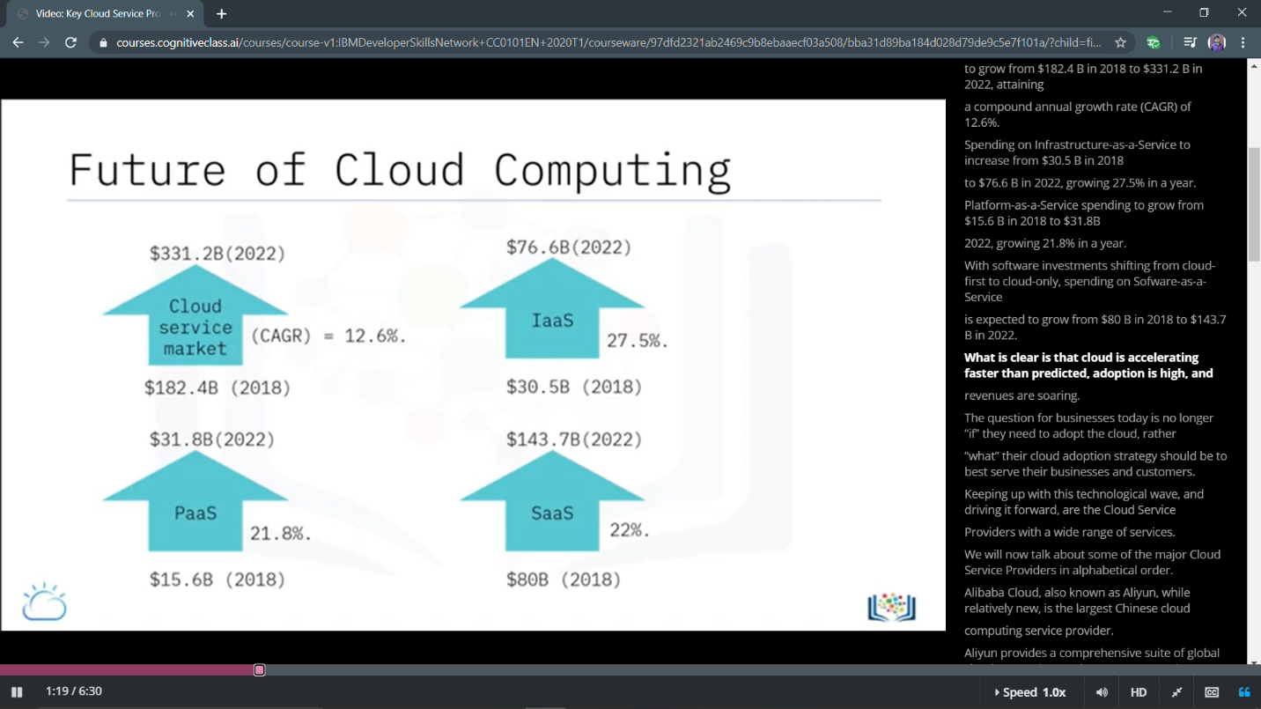

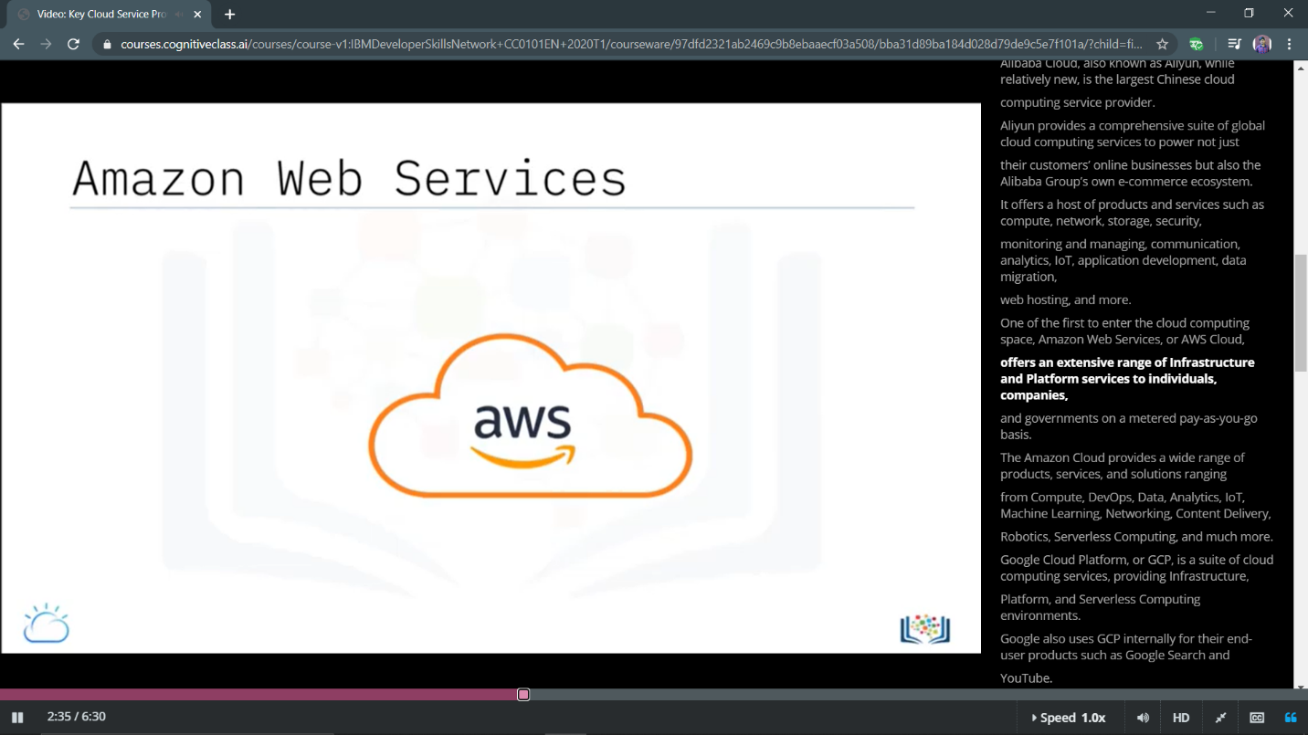

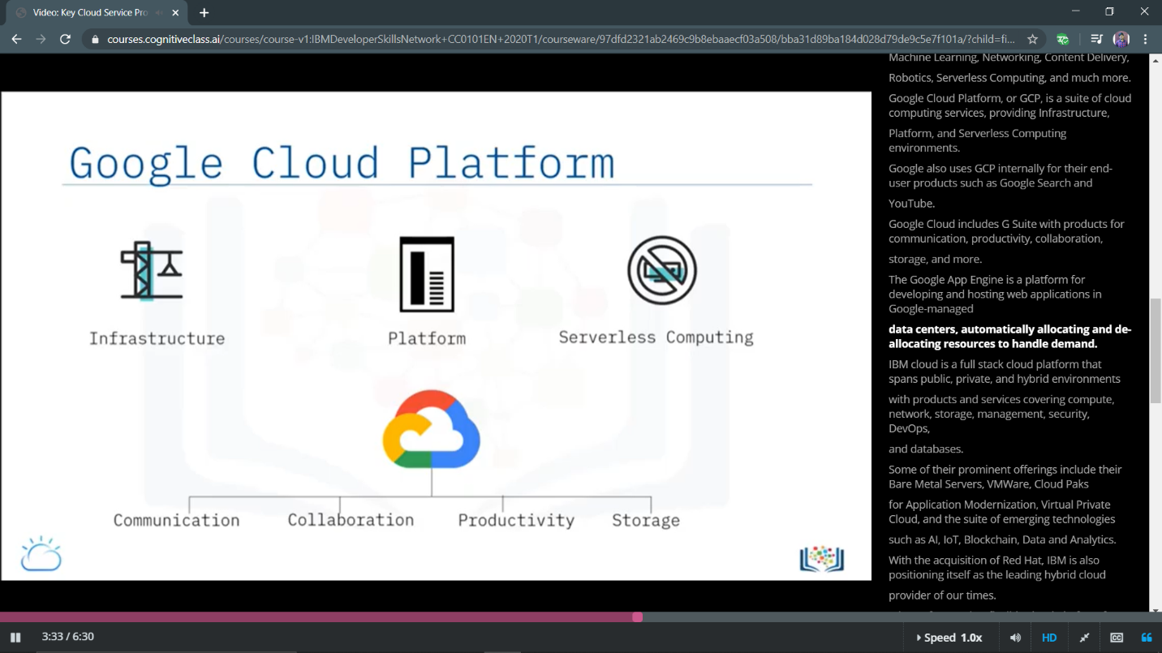

**Progress of Module-1**

